**APACHE ANT FUNDAMENTALS**

# Introduction to ant

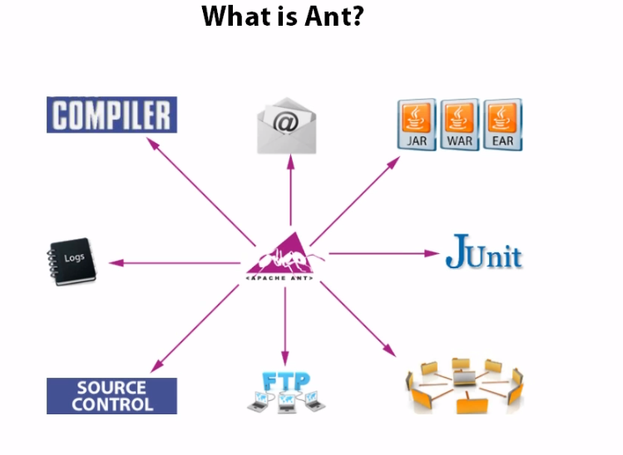

## Ant structure

make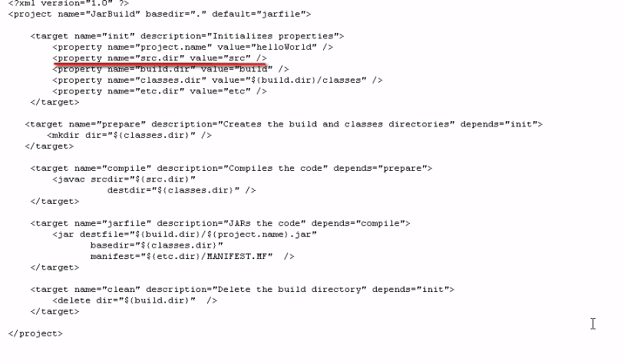

Make directory

To ensure we always a fresh again

Where are manifest file will reside

Where the compiled classes will be located

Where place our completed jar file

Location of the source code

Name jar file

* make directory create directory if it does not exist. It will also recursively create. It will also recursively create.

## Run ant from IDE

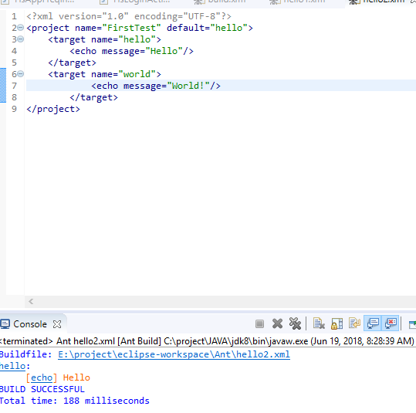

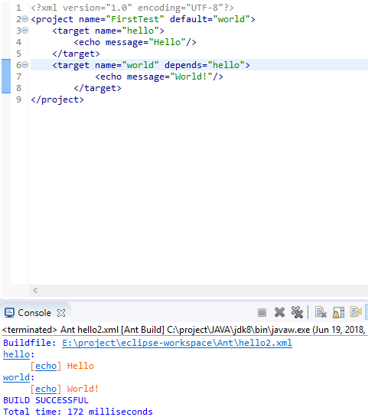

Buildjar.xml

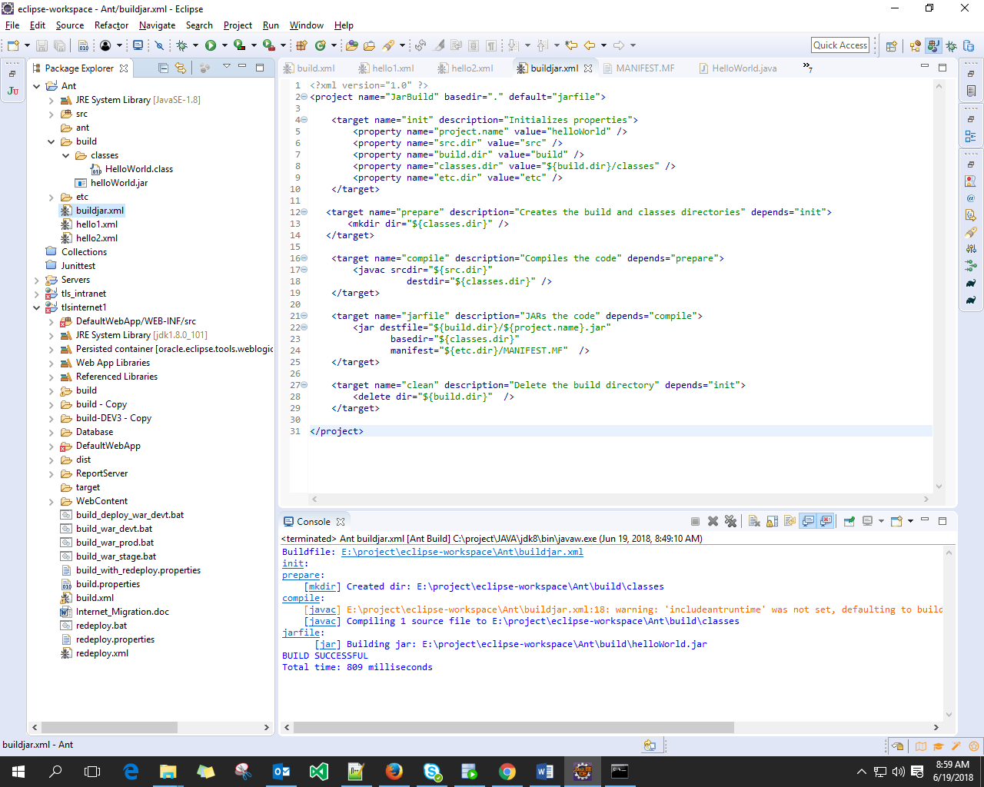

creates a manifest file.

This task can be used to write a Manifest file, optionally replacing or updating an existing file.

## Run CMD when build isn’t default

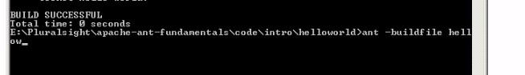

# Ant Tasks

## Compile Tasks

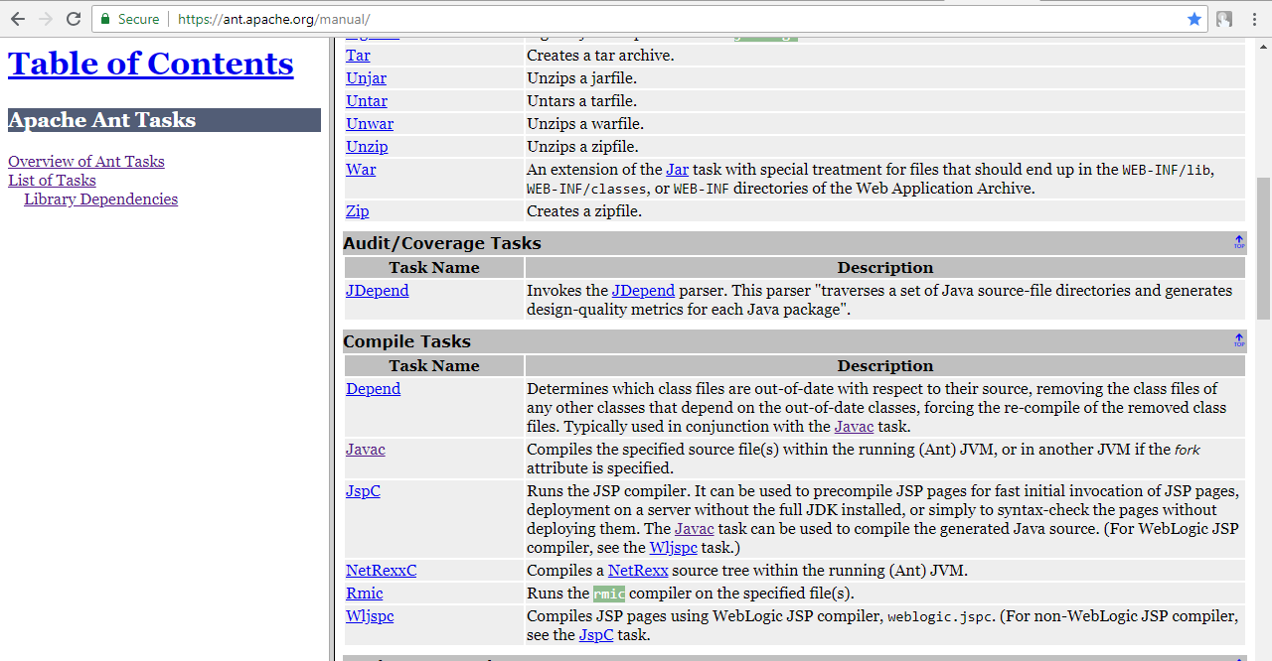

## Archive Tasks

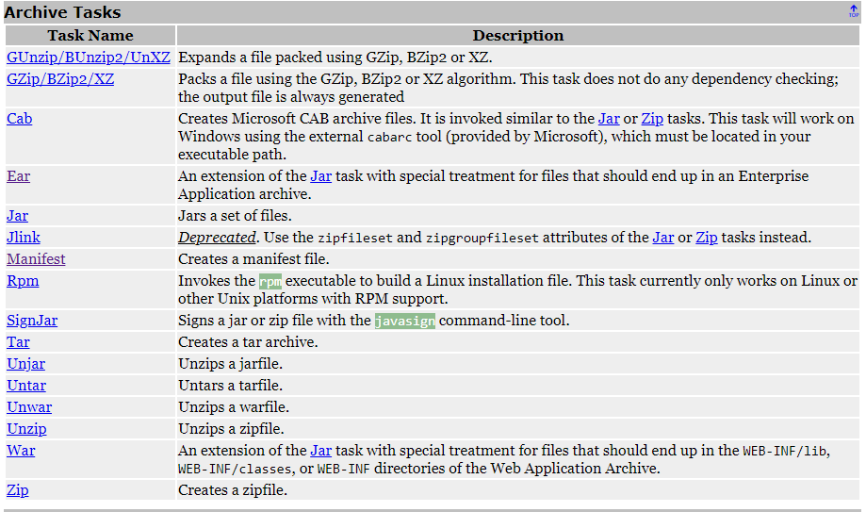

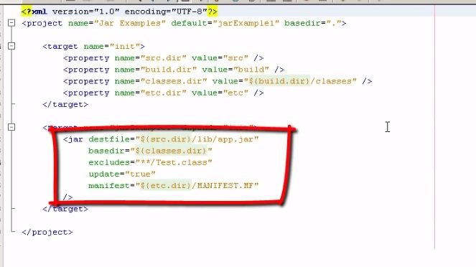

Do or don’t overwrite the jar file

* E

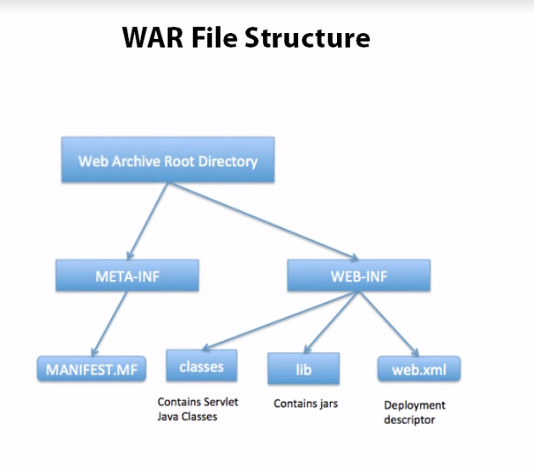

* Example

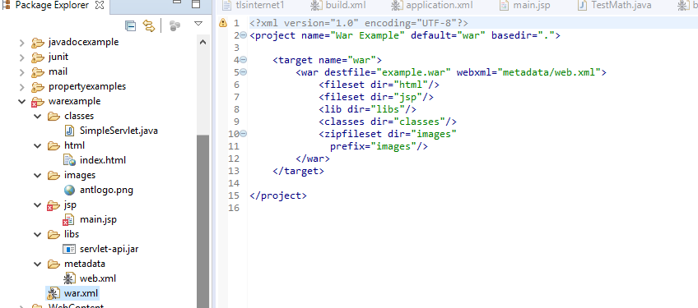

Result after running build

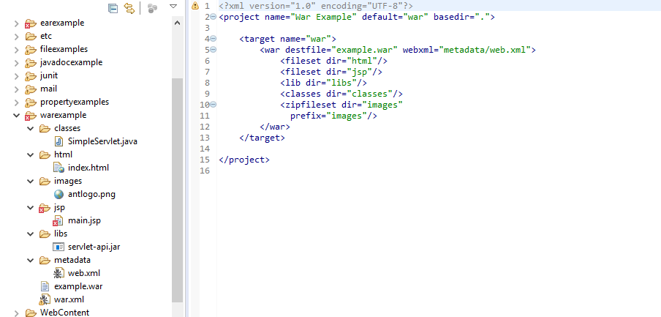

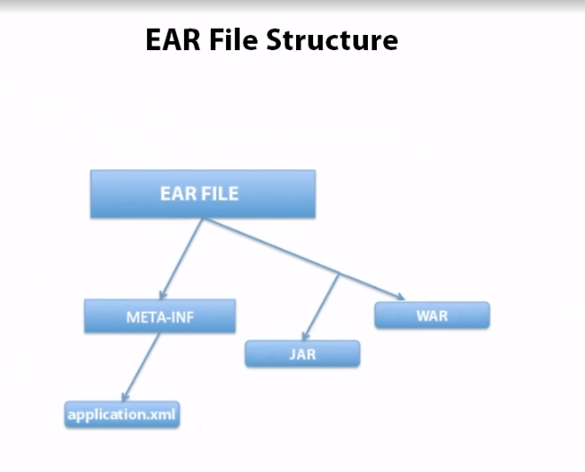

* Example

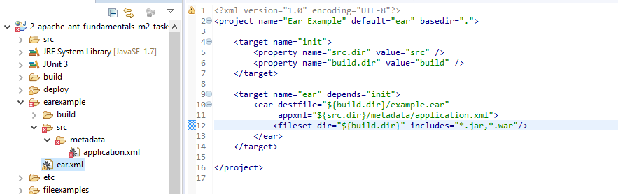

Result

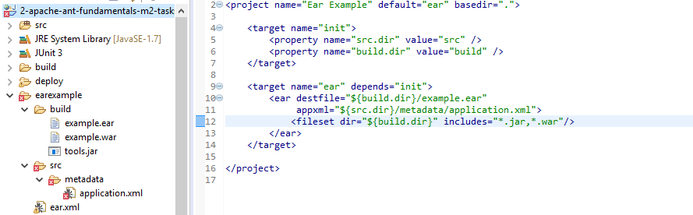

## File tasks

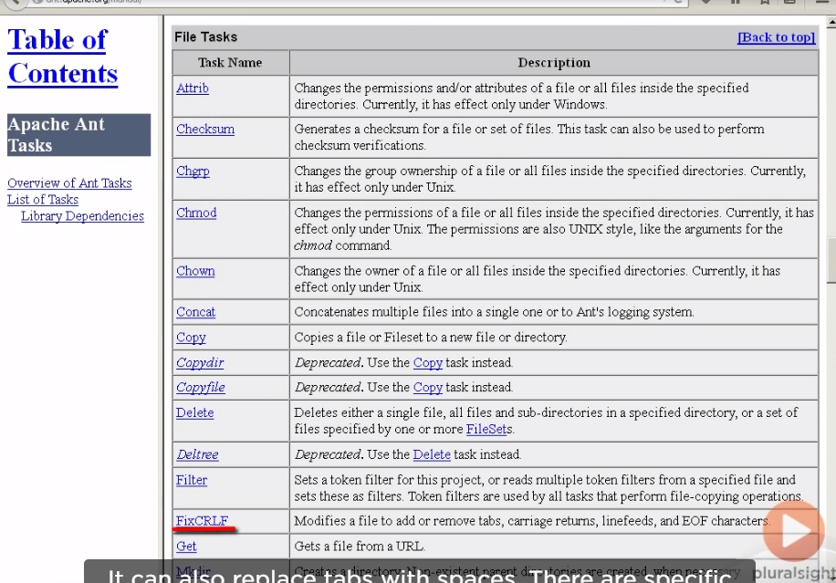

* 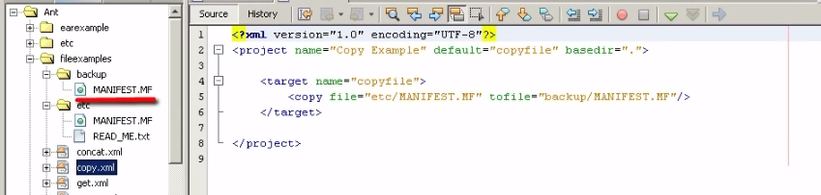Copy task
* Move task

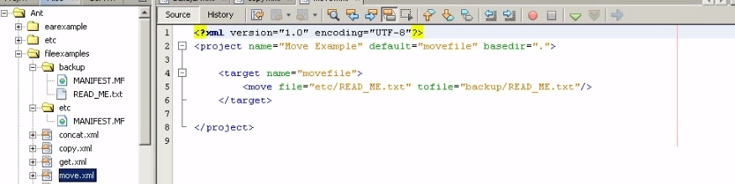

* sync task is used to sync the backup directory to anything that changes within the et cetera directory.

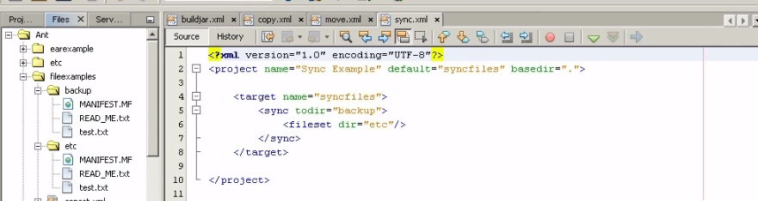

synchronize

* get task is used to download file from any URL

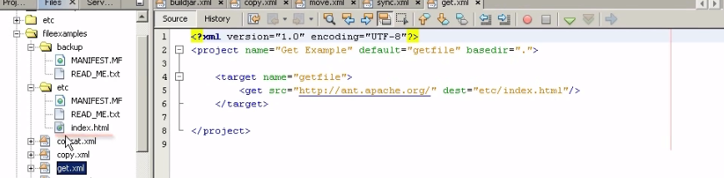

* replace task

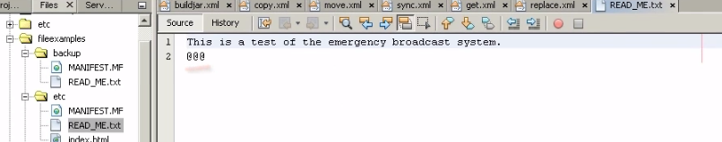

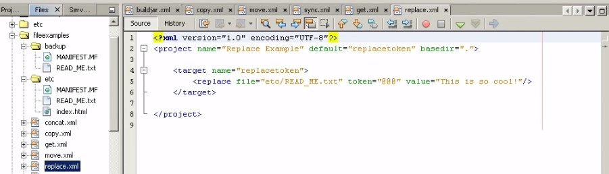

Result

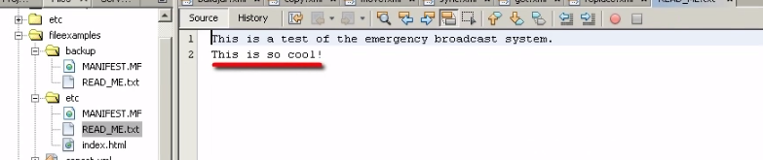

* 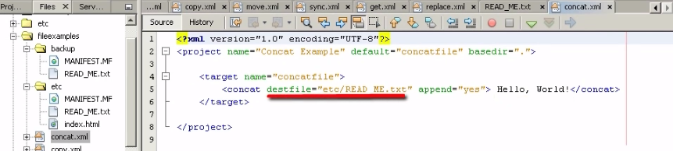concat task can be used to concatenate one or more resources to a single file

can concat multiple file to new one file

Result

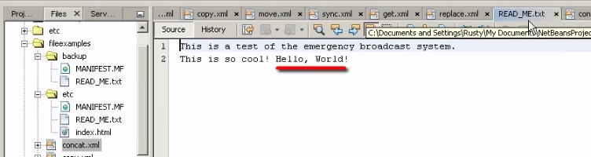

## JavaDoc tasks

Tool for generating java documentation

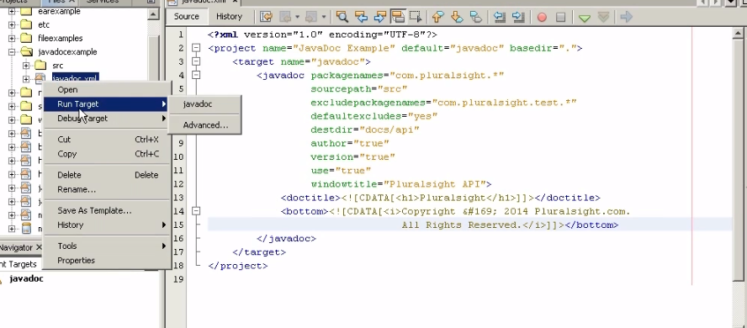

Defaultexcludes java package

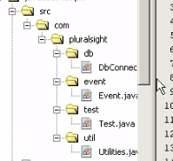

Result

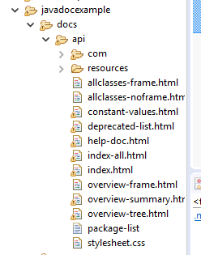

## Property tasks

Property file can be essential for specifying different properties for multiple platform and environments

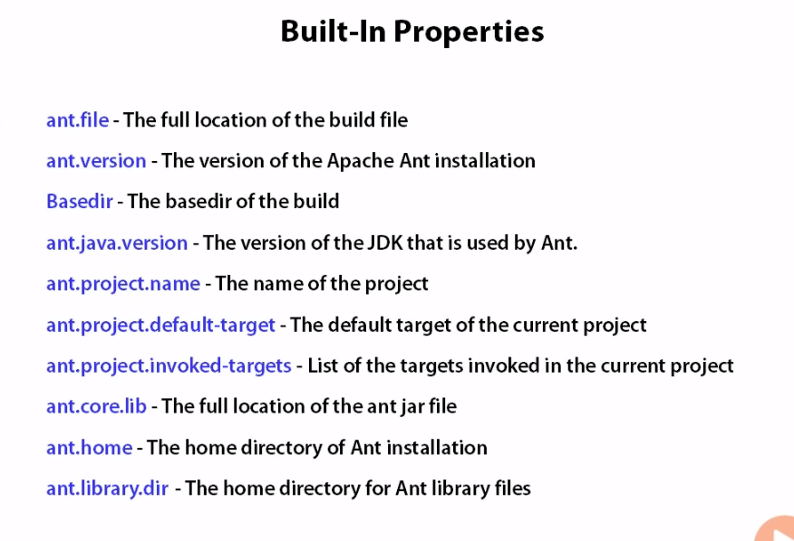

In build.property

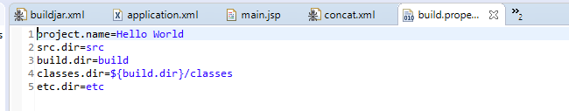

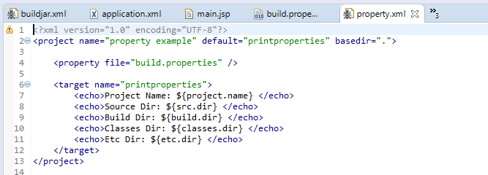

Result

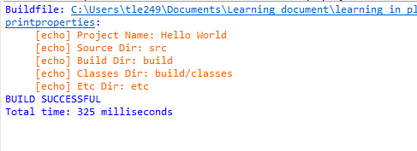

* **Propertyfile Task** can create or edit property file, writing entries of name value pairs to a property file

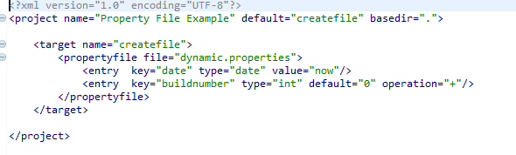

Create file dynamic.properties

Result

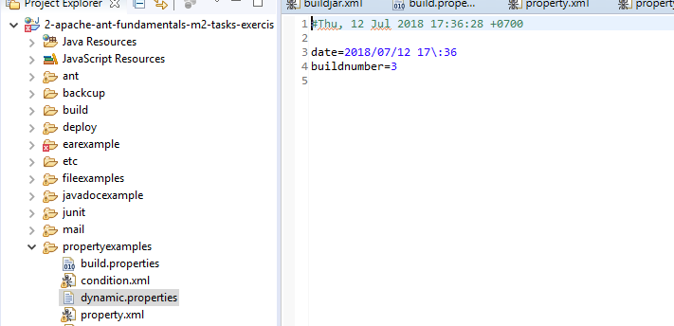

* **Condition task**

It it useful for Checking if certain condition hold true

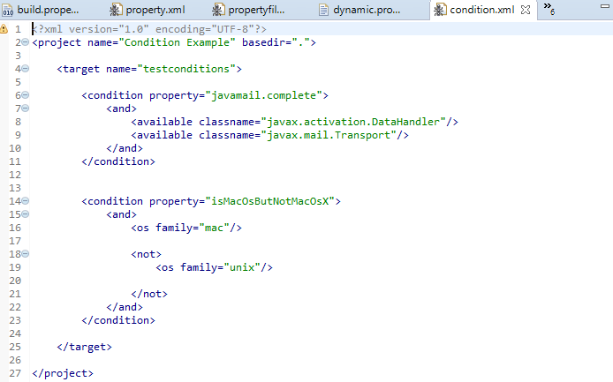

Set property only if these two classes are available in the class path then available would be set true

* **Xml property task**

Property name

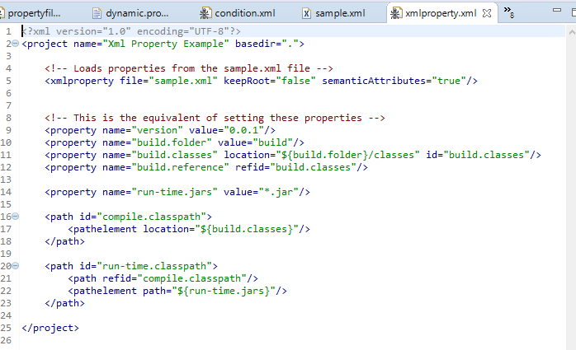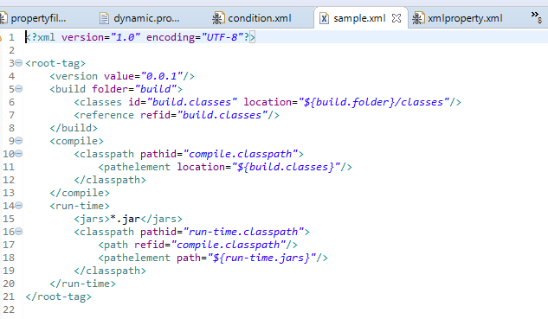

Passing value

Using property files can be essential for specifying different properties for multiple platforms and environments

## Version control tasks

* Provide tasks that interact directly with several version control systems , allow to check out, check in, and update code from a build file

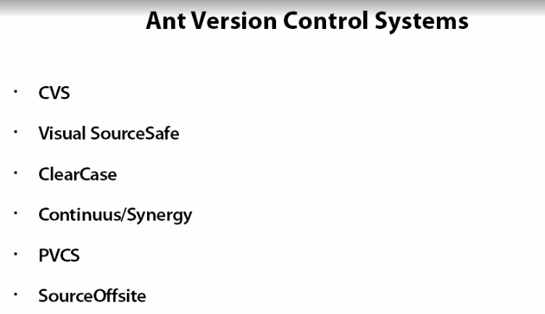

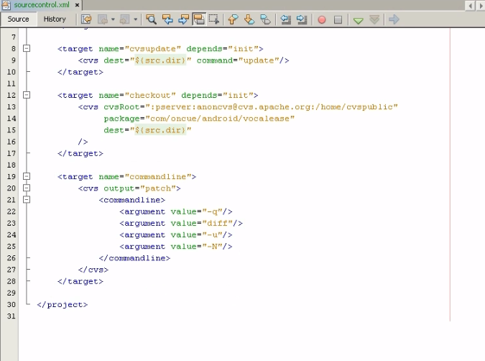

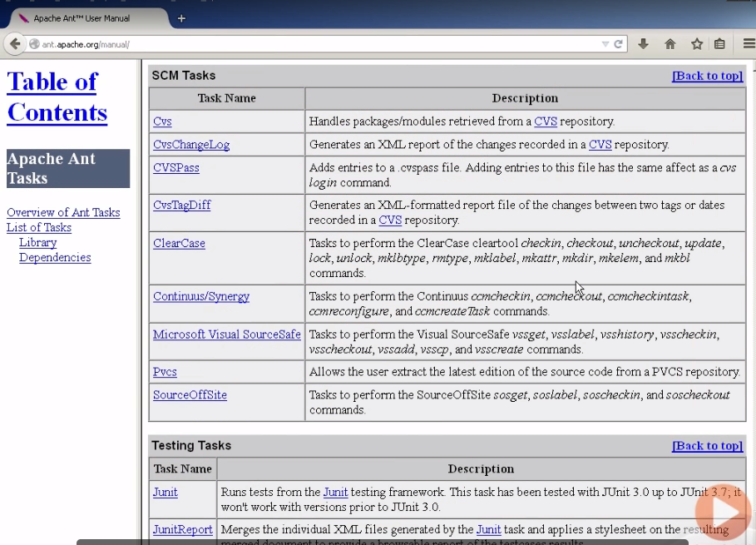

## Junit tasks

Automatically run junit tests

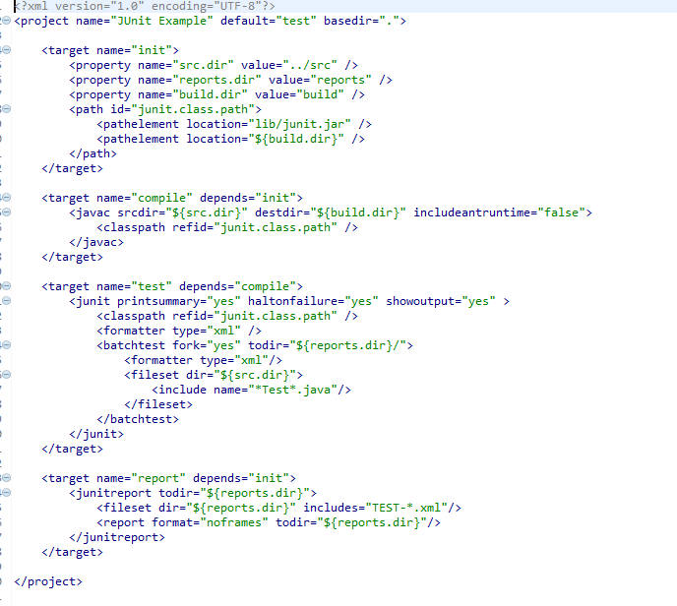

Reusable class path

For each test case to the console haltonfailure equal yes, don’t want to build if any of the test fails

Call junit test

Compile java code to build directory

Define class path, necessary for the junit test to run

## Mail tasks

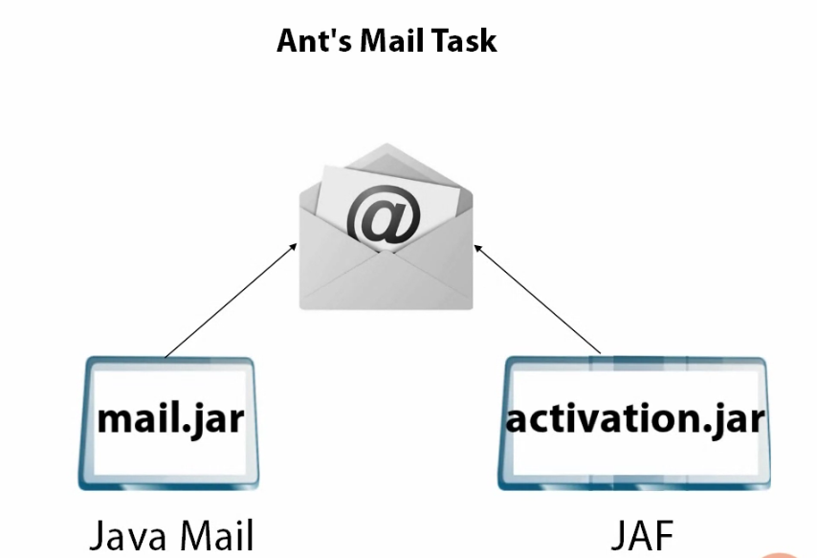It’s ability to send SMTP emails. The mail tasks serves this purpose

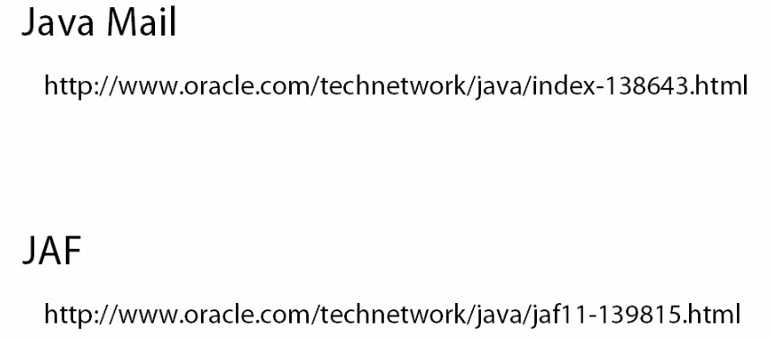

* Create file report.zip to add an attachment to our email

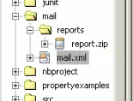

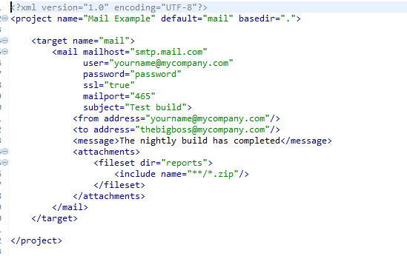

Result

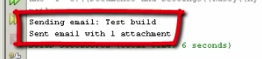

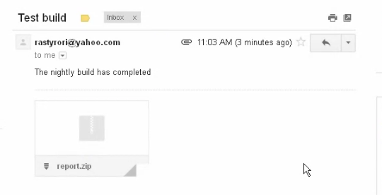

## Remote tasks

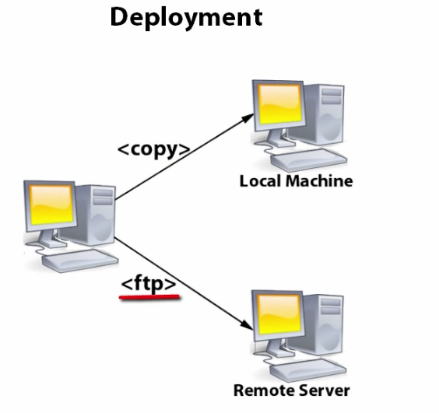

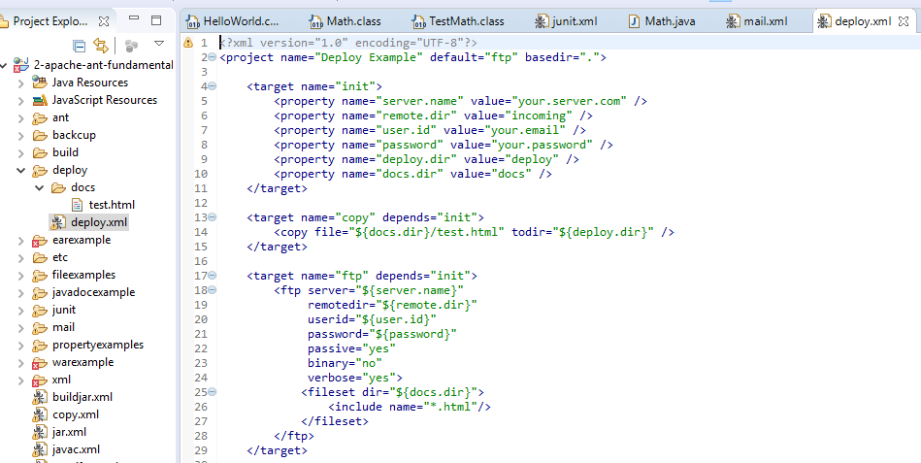

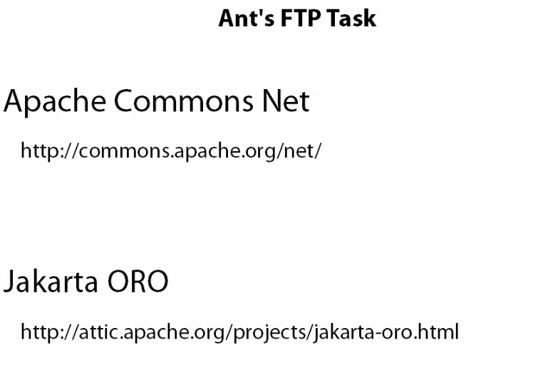

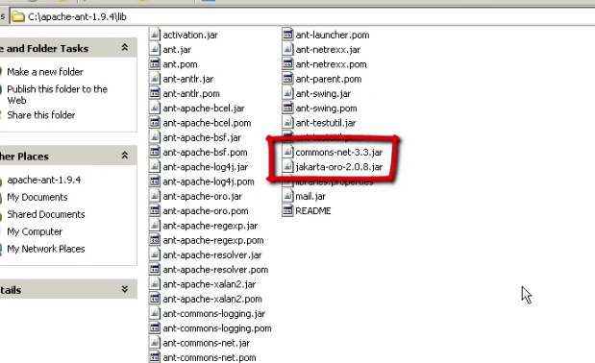

## XML tasks

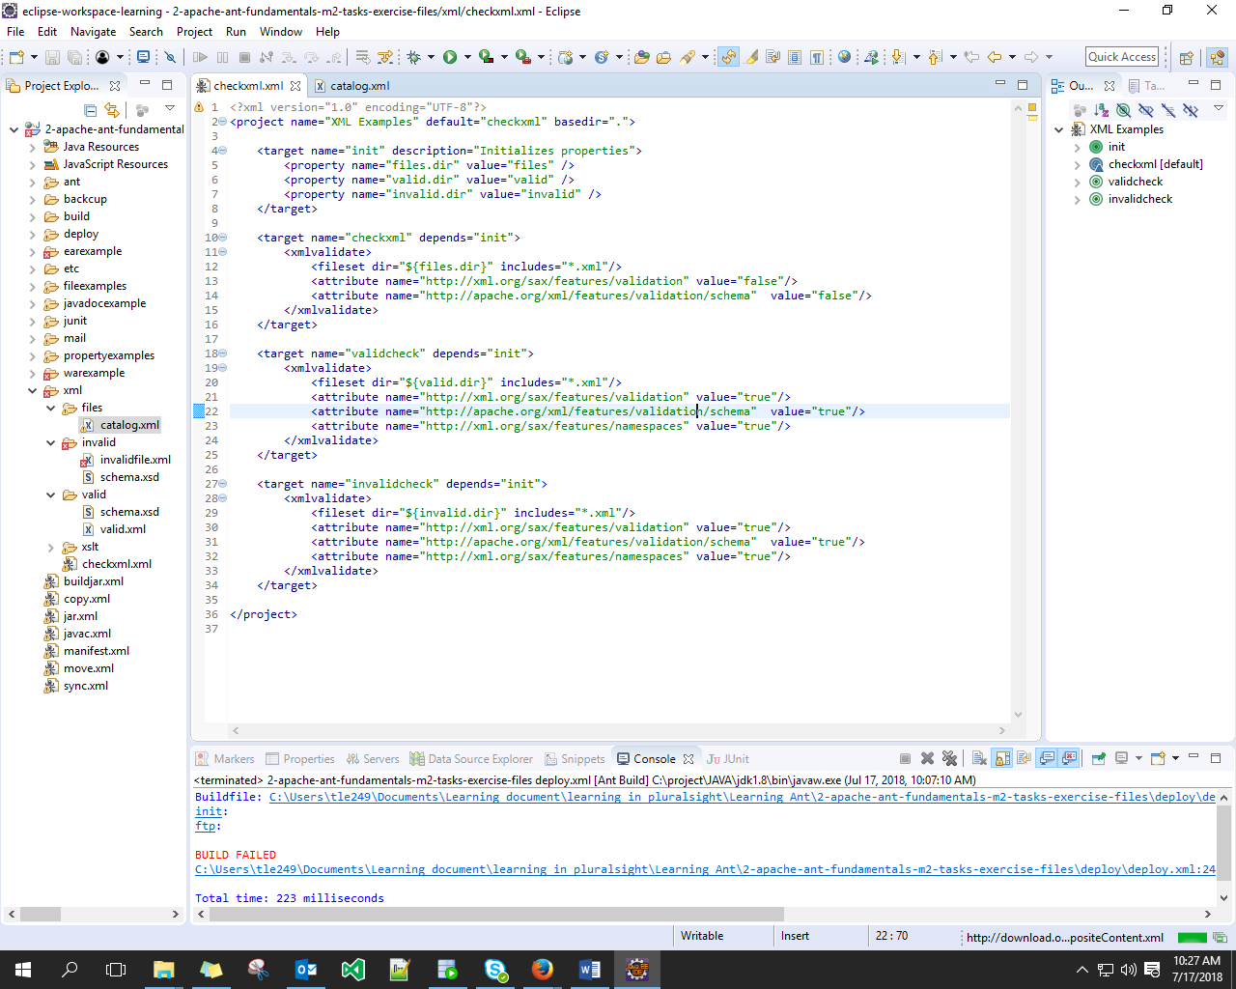

# Ant elements

## Overview

## PatternSet

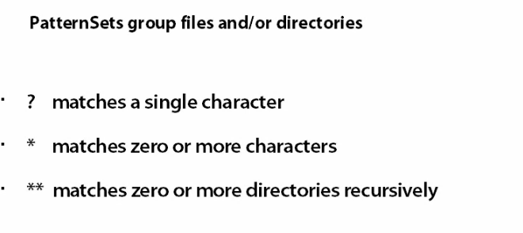

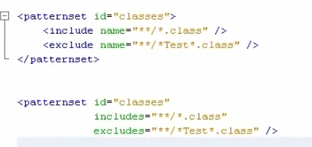

reusable

## DirSet

Allow apply the pattern

## FileSet

FileSet is almost exactly the same as DirectorySet except it select groups of files base upon pattern rather than directories

Common file such as cvs files,temp file, and backup file will automatically excluded

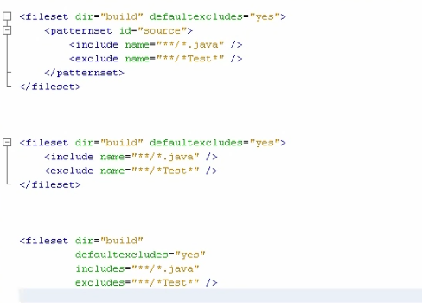

## FileList

FileList allow to select specific files using its files parameter listed as a comma sepatated list. Pattern are not allow here

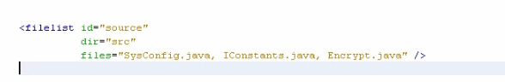

## FileMapper

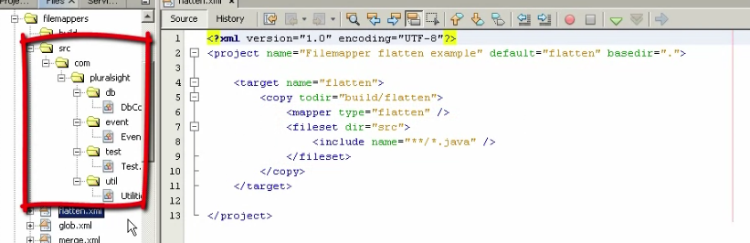

Result

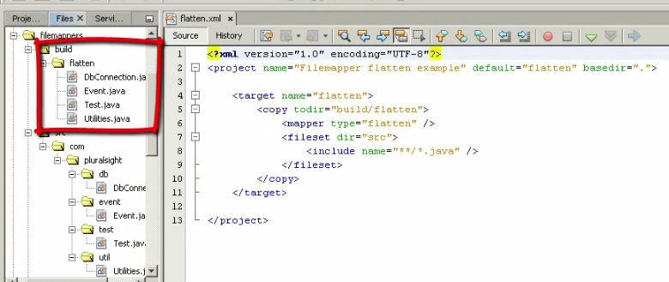

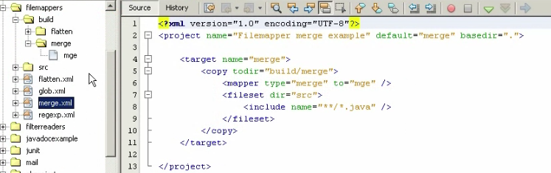

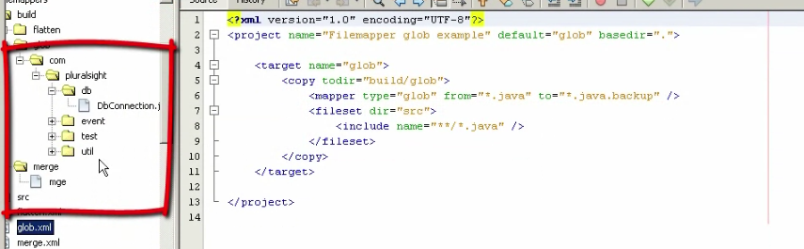

Rename file

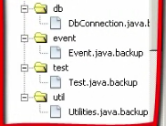

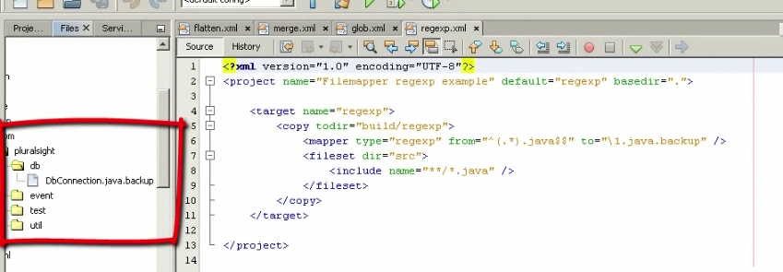

Rename file use regexpression

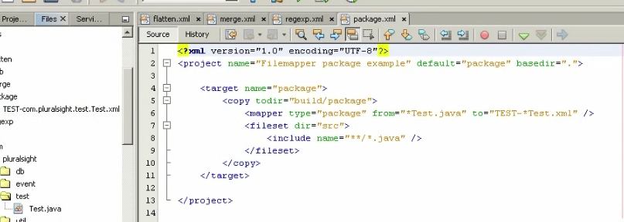

Rename file test

## FilterReader and FilterChain

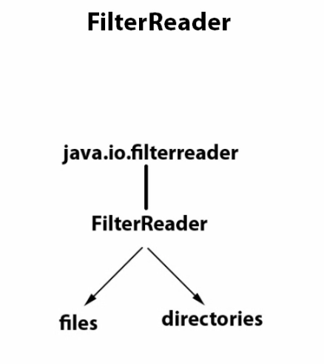

Read and filter data from files or directories

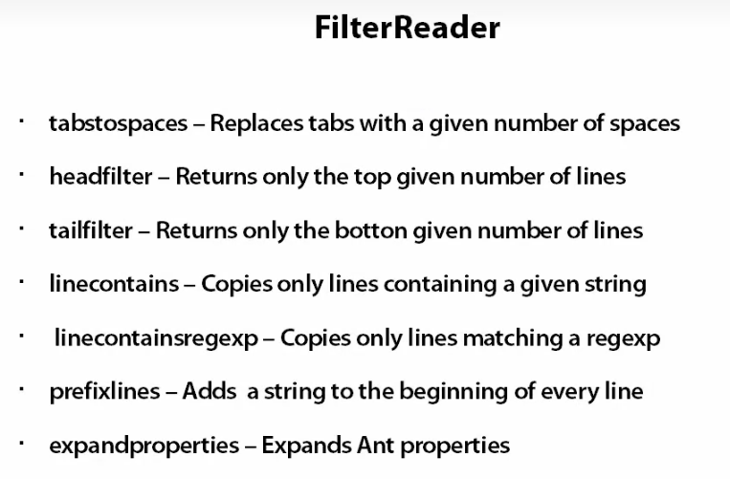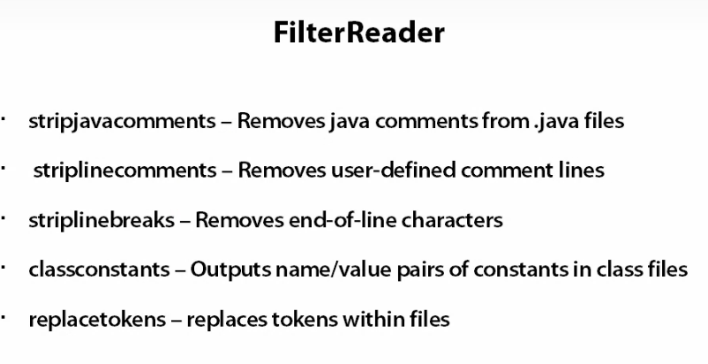

* 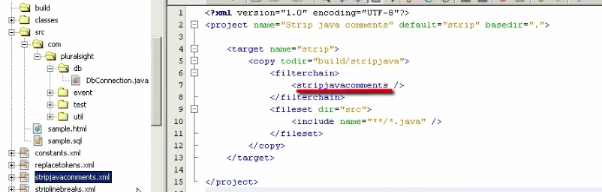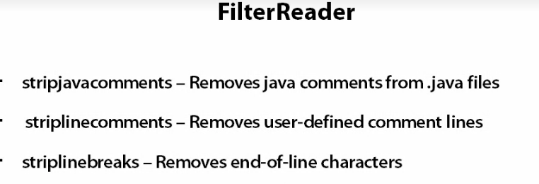stripjavacomments

File java contain comment

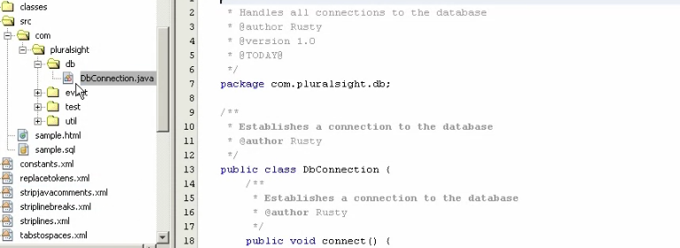

Result after run file stripjavacomments.xml

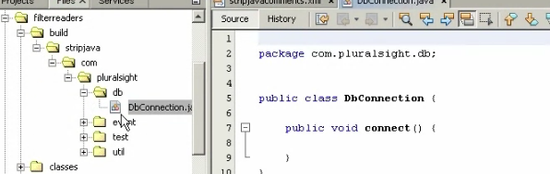

* Striplinecomments

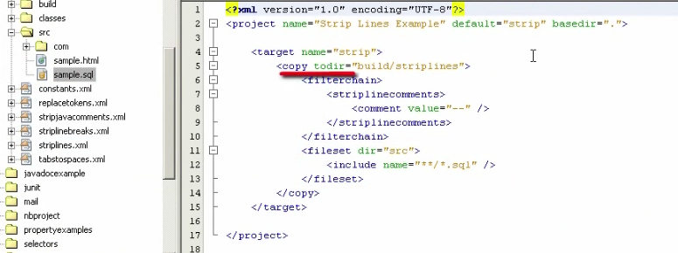

File SQL contain comments

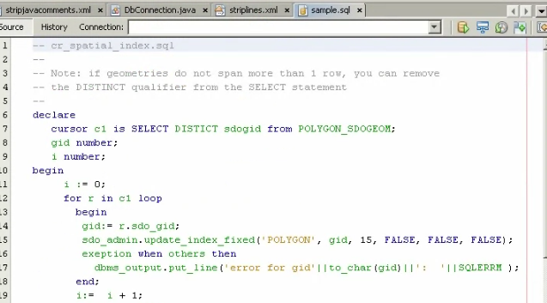

Result after run striplinecomments.xml

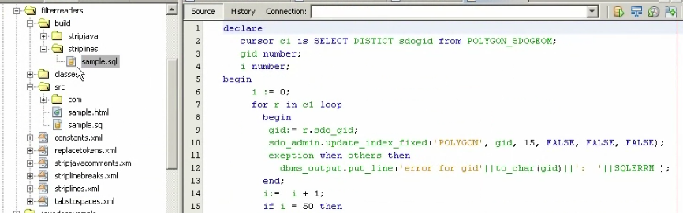

* Striplivebreak

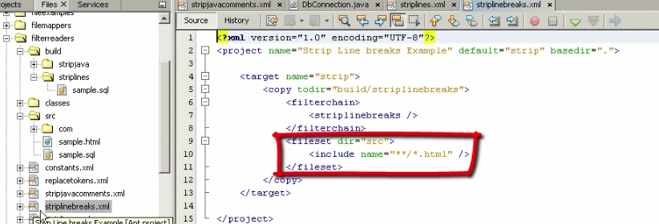

File HTML

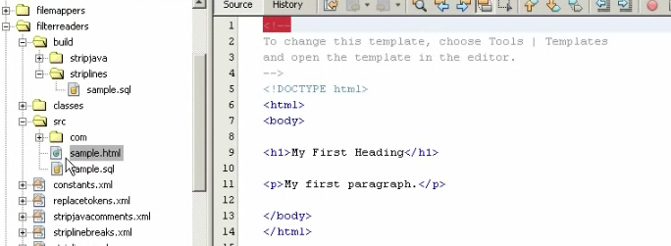

Result after run striplinebreaks.xml

* All break are remove

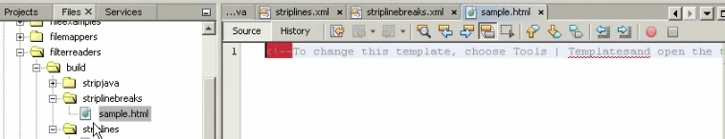

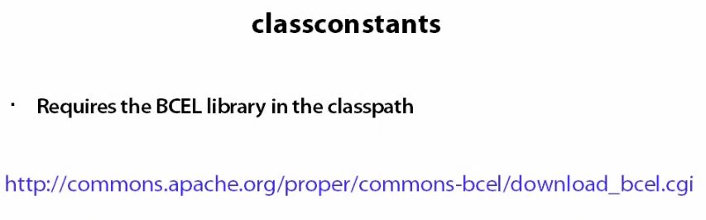

Download lib and add into classpath

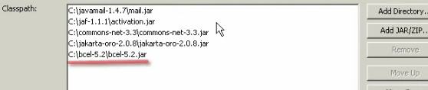

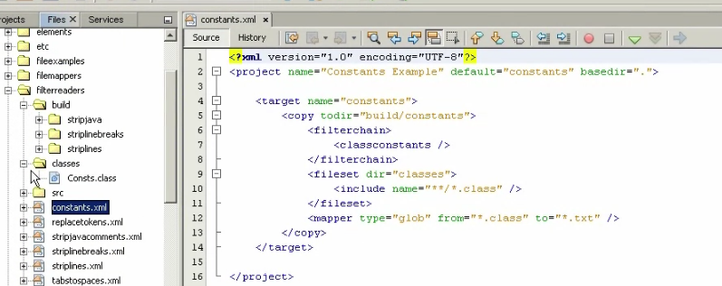

Result

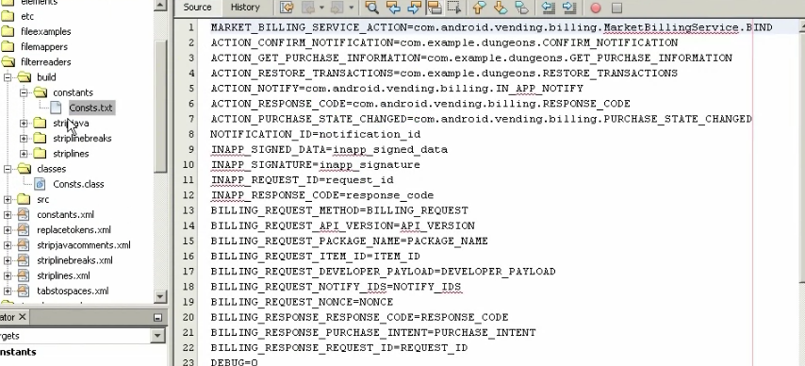

* Replacetokens

Want to copy all java files to another directory and add timestamp to each files

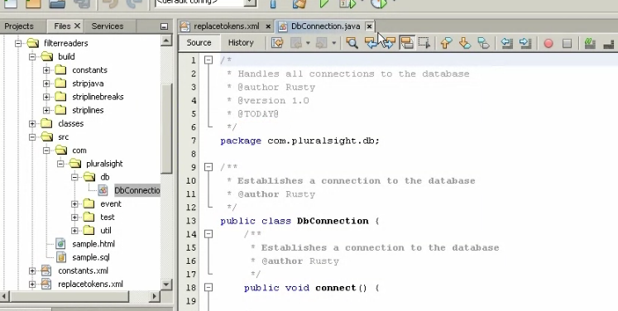

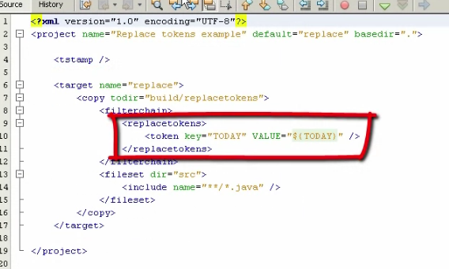

Result

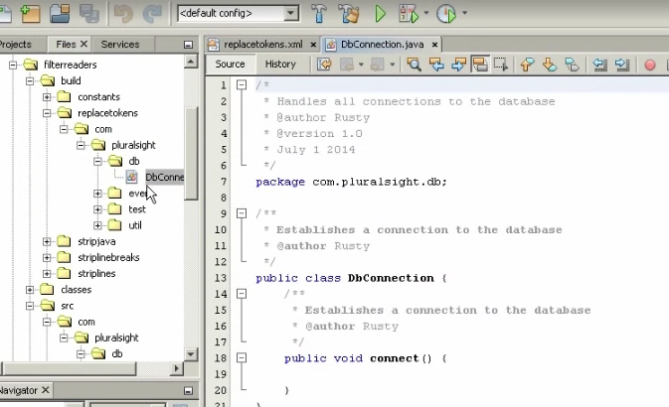

## Selectors

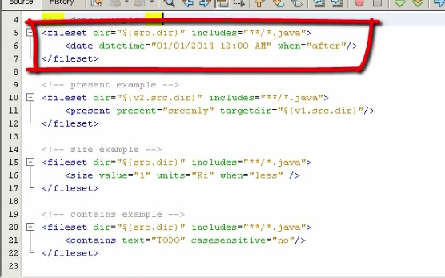

Select file based upon their modification date

Select a file that only present in version 2 src and not present version 1 src

Select only file in the directory less than 1k in size

Select file only contain specific string

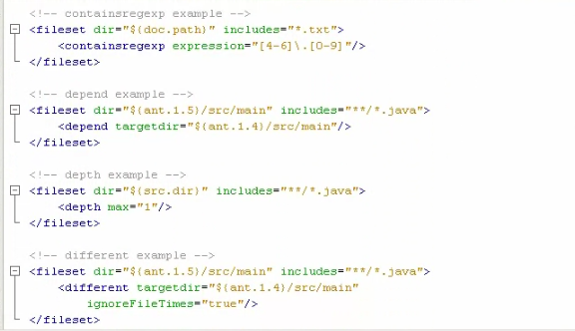

Select file that have been modified more recently then equivalent file else where

Select contain regeler expression

* We can combine selector by and, or ,no, not

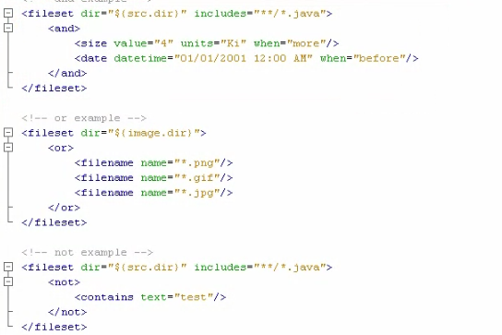

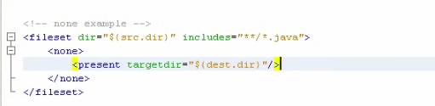

Select file that not present in destination directory

## ClassFileSet

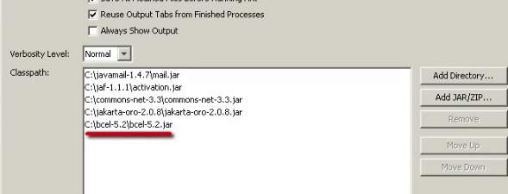

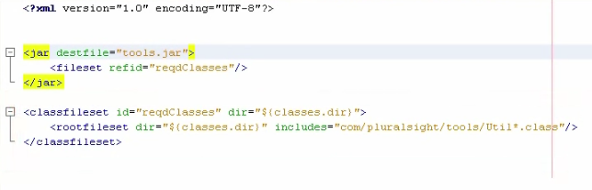

Define the root classes and all file upon which the root classes depend will be included

## Paths

Ant make dealing with paths much easier and less prone to error

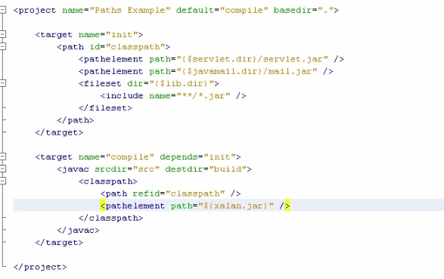

## Listeners and loggers

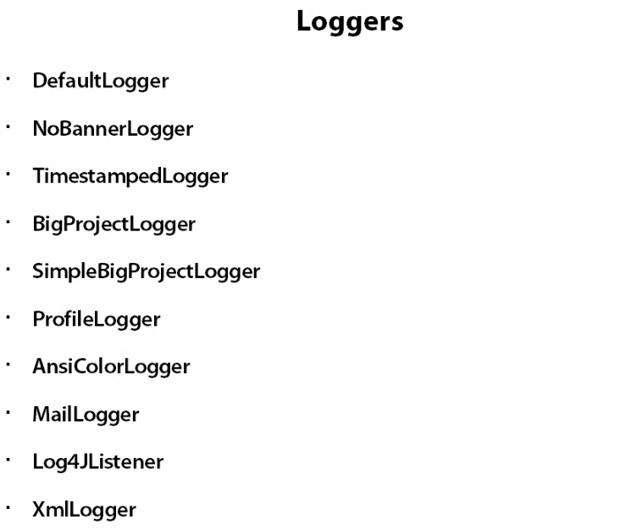

# Full example

## End to end build

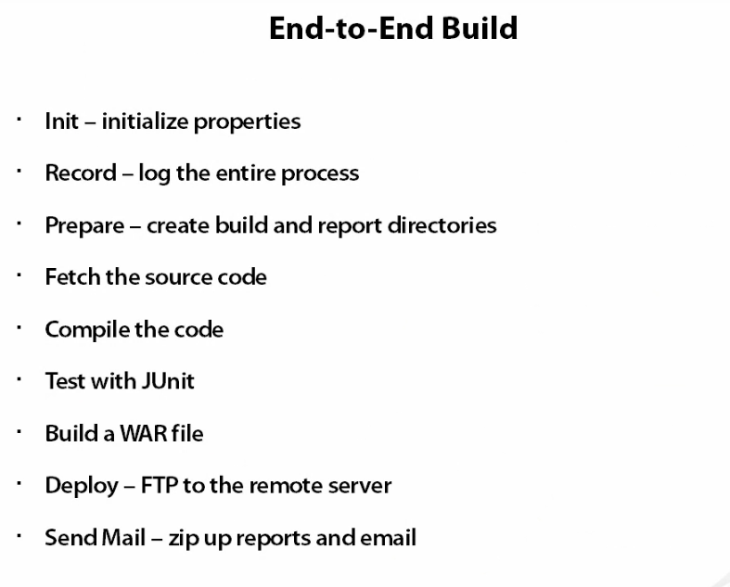

## Building a skeleton

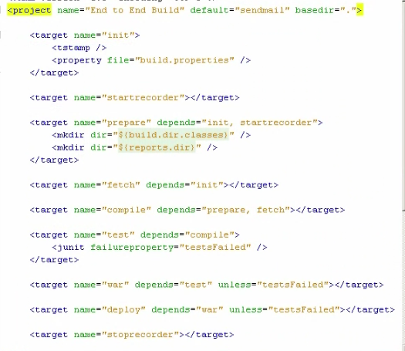

Not to excuse if testfailed is true

variable

Ensure latest code

Make new directory and report

Want to begin logging everything that happen as soon as possible

Can later use the dstamp variable

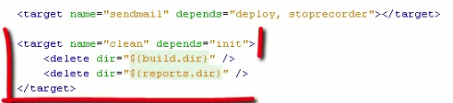

## Defining properties

## The init task

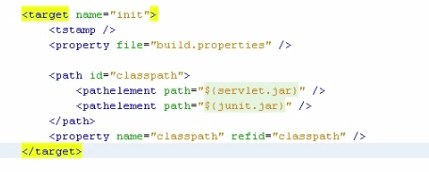

servlet.jar=C:/java-servlet/servlet-api.jar

junit.jar=C:/junit3.8.1/junit.jar

Similar with value

## Starting and stopping logging

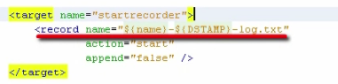

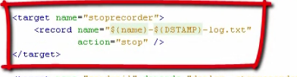

## The prepare task

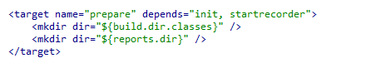

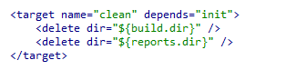

## Fetching the source code

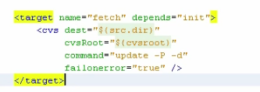

Cause the entire build process to terminate

Update command

Dash -p: which delete any empty directories

Dash -d: create new directories

## Compiling

Java c

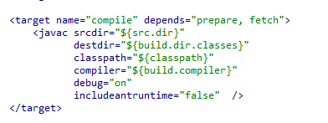

## Testing with Junit

Create variable boolean

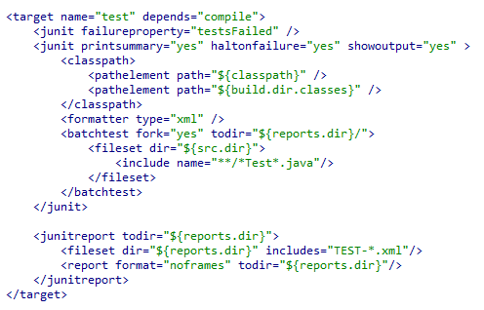

If many file aggregate them together

Use the junit report task to convert it to HTML

Call the test class and designate the report directory for it

## Building the WAR file

the war file is just a jar file with the condition of the web.xml file

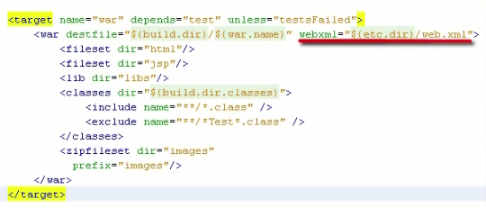

Where the web.xml file is located and it’s in the cetera directory

## Deploying

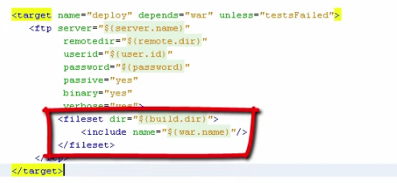

## Sending email reports

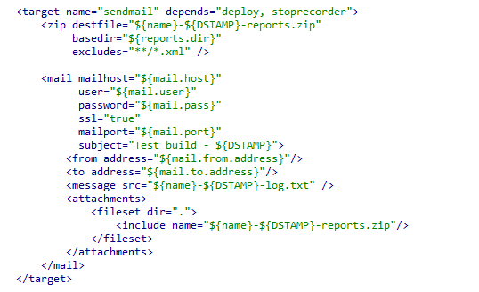

Zip all those report into one file to attach

## Running the Example

# Course summary

## Extending ant

